

Final Project

CPS3740: Database Management System

|  |  |
| --- | --- |
| Student Name: | Huang Yawen |
| Student ID: | 1194921 |
| Lecture: | Dr. Hemn Barzan Abdalla |
| Section | W02 |

Fall 2023-2024

**Database Management System CPS3740**

**Final Project documentation Deadline: 12-04-2023**

* To answers questions below first you need to create a **schema** which contain at least **four tables**
* Include the constraints like **NOT NULL, UNIQUE and CHECK** constraints in all the table.
* Insert minimum **three** records in each table.
* Retrieve the data using operators **(in, between and like).**
* **Three queries** must be there from **SET operators (Union, intersect)**
* **Three join queries** must be included out of which **three** must be outer joins.
* **Three nested queries** must be included (Inner Query and Outer Query).
* **Two queries** must be included using **group by and having.**
* **Minimum two views**, which combined of two or three tables, must be included.
* **One cursor and trigger** must be included.
* Create an **application** for your MySQL schema. (Python)
* Must have the **main form page**.
* Each table must have (**continues** form with **single** form).
* For two tables should have a **report**.
* The user when open the database must directly show the **main form.**
* Give the summary for your project plus what you learned in this semester, must be less than 300 words.

**Instructions**

* Create a word document which includes details and the screen shots of all the queries as said the above.
* The first page that document contains the information about the student like name, ID Number, with section number.
* Use the attached template to prepare your final project document (**Don’t include Normalization).**

**Answers:**

1. To answers questions below first you need to create a **schema** which contain at least **four tables**
2. Include the constraints like **NOT NULL, UNIQUE and CHECK** constraints in all the table.
3. Insert minimum **three** records in each table.

**The schema is called project.**

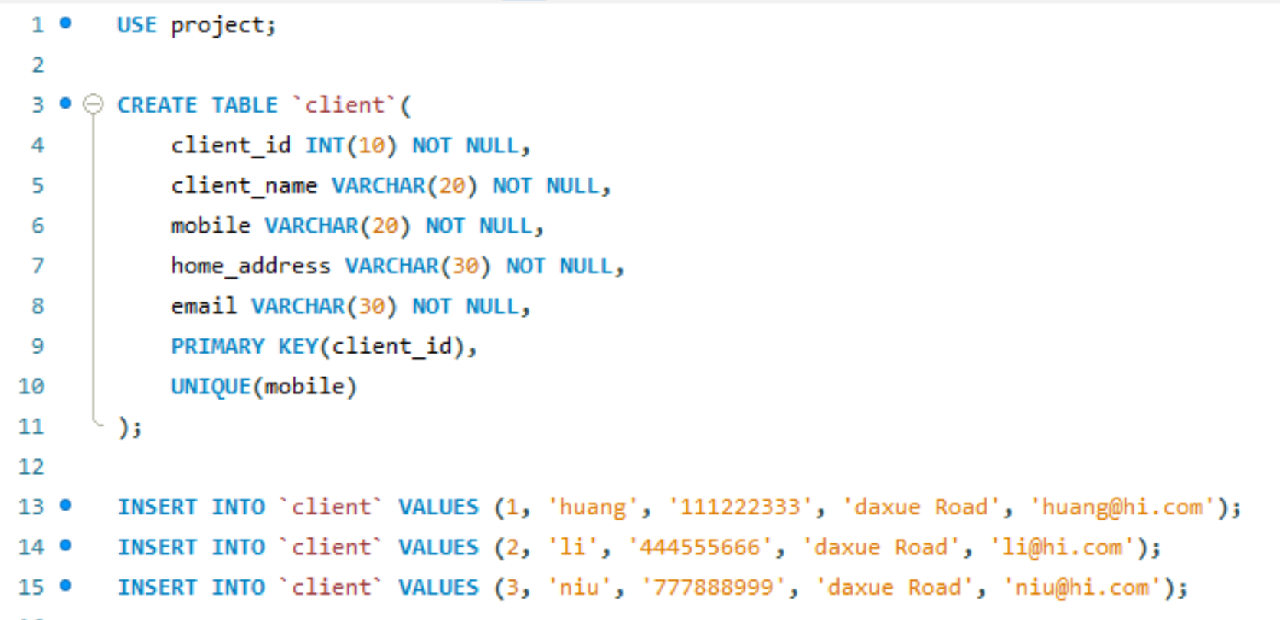

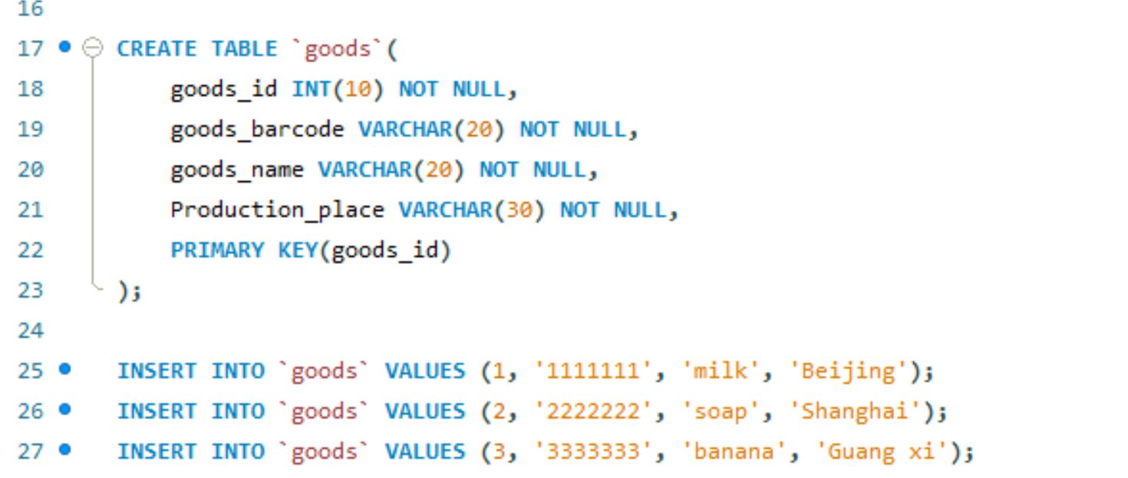

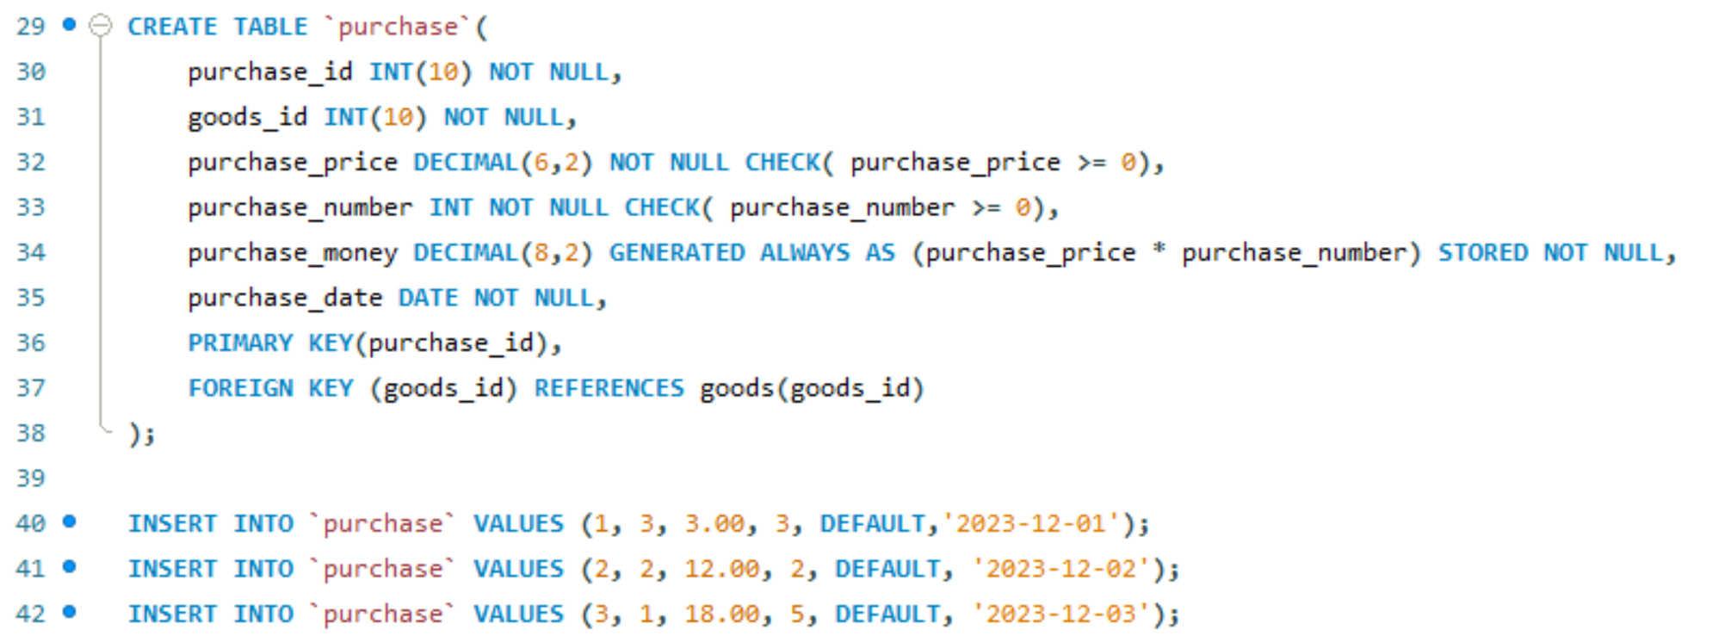

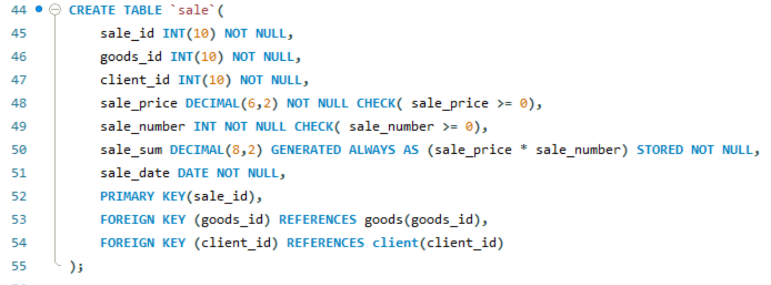

The diagram for these four tables:

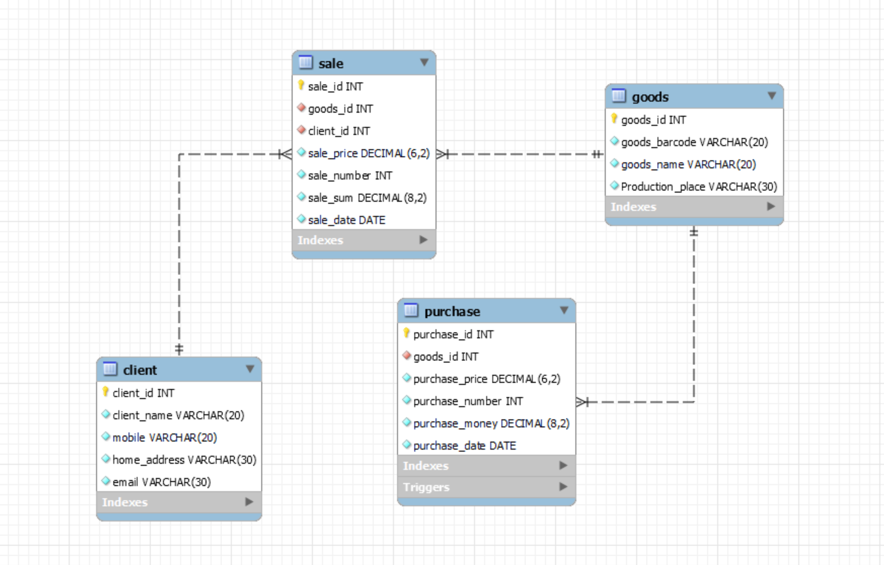

The table is display like:

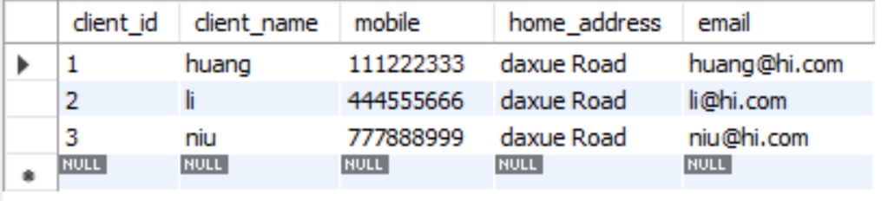 (client)

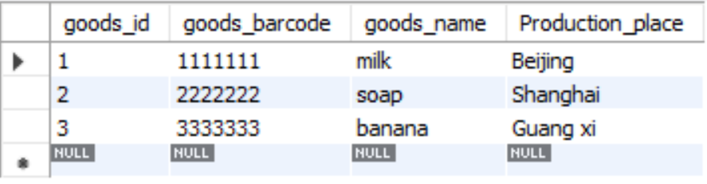 (goods)

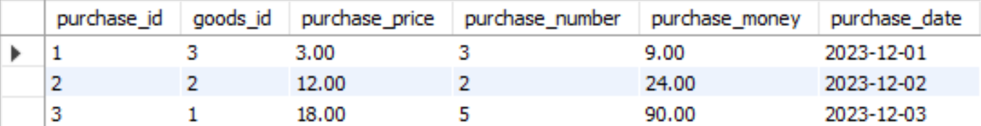 (purchase)

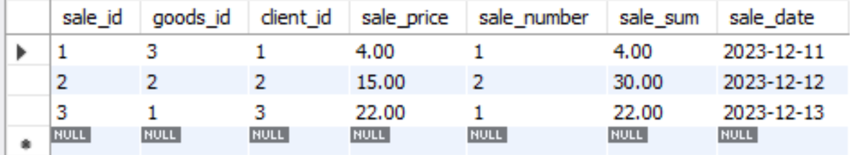 (sale)

1. Retrieve the data using operators **(in, between and like).**

**IN:**

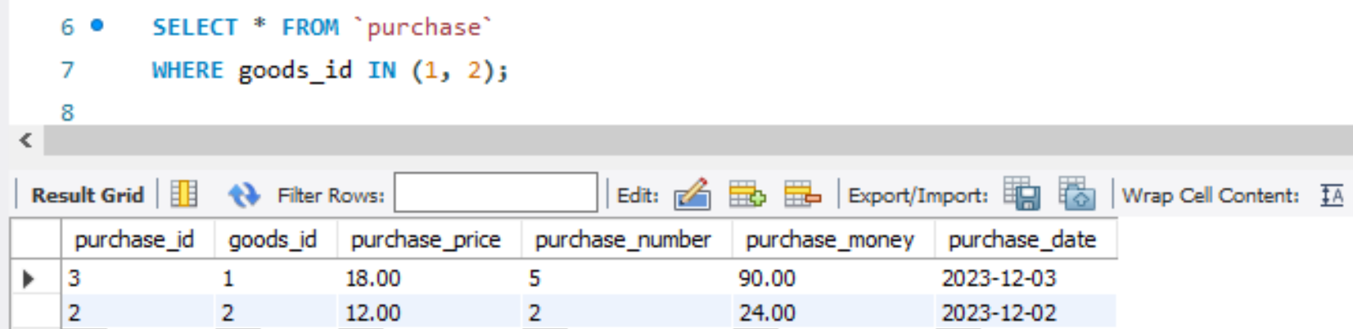

**BETWEEN:**

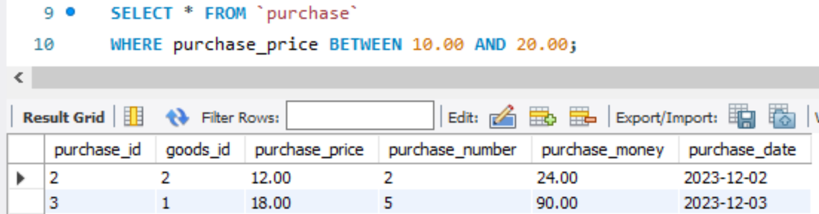

**LIKE:**

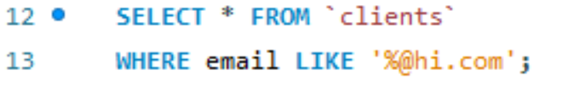

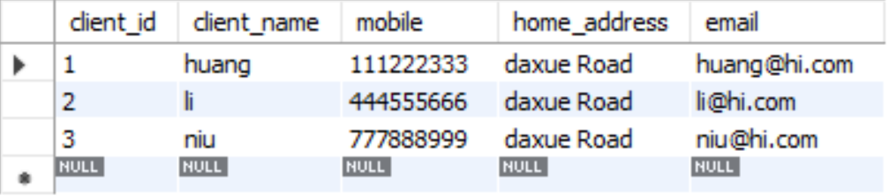

1. **Three queries**must be there from**SET operators (Union, intersect)**

Using **UNION** to combine records from the **purchase** and **sale** tables:

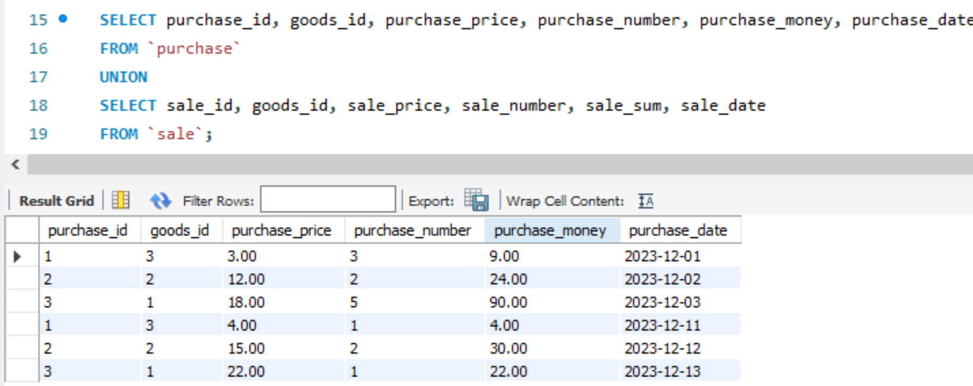

Achieving **INTERSECT** to find goods that appear both in purchases and sales by:

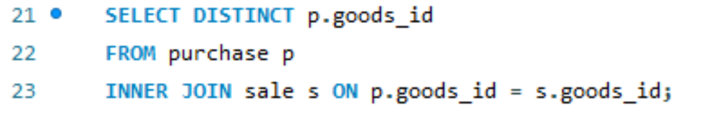

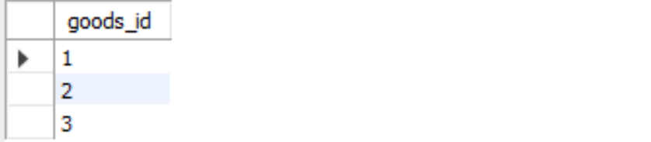

Using **UNION** to retrieve a distinct list of goods IDs from both the purchase and sale tables

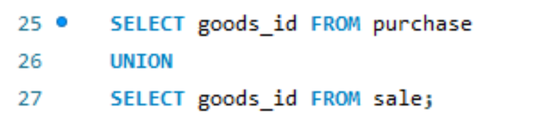

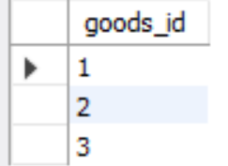

1. **Three join queries** must be included out of which three must be outer joins.

**LEFT OUTER JOIN:**

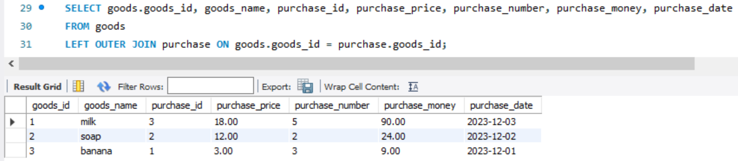

**RIGHT OUTER JOIN:**

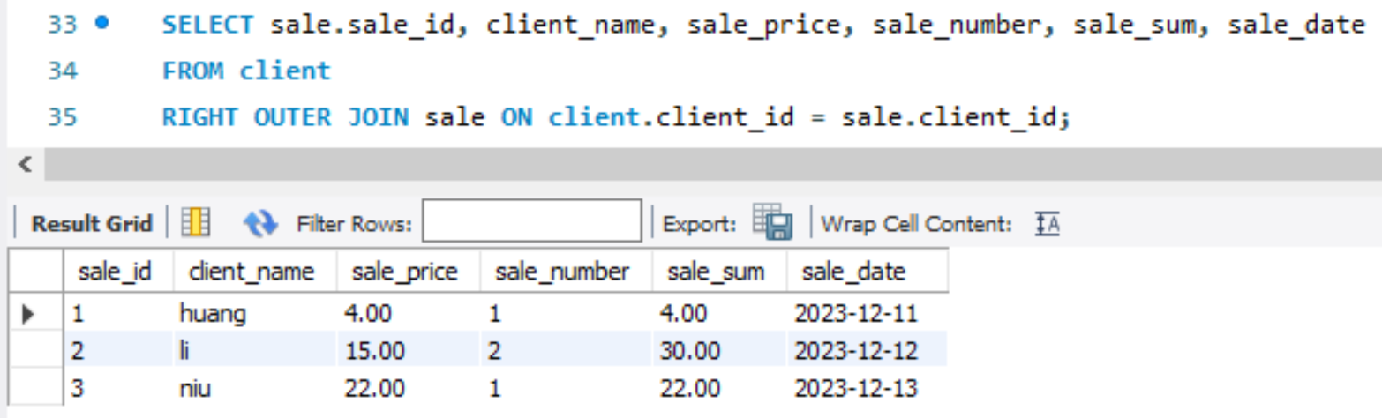

**LEFT OUTER JOIN: (another one)**

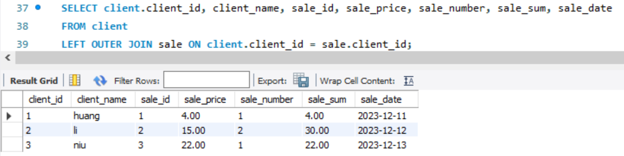

1. **Three nested queries**must be included (Inner Query and Outer Query).

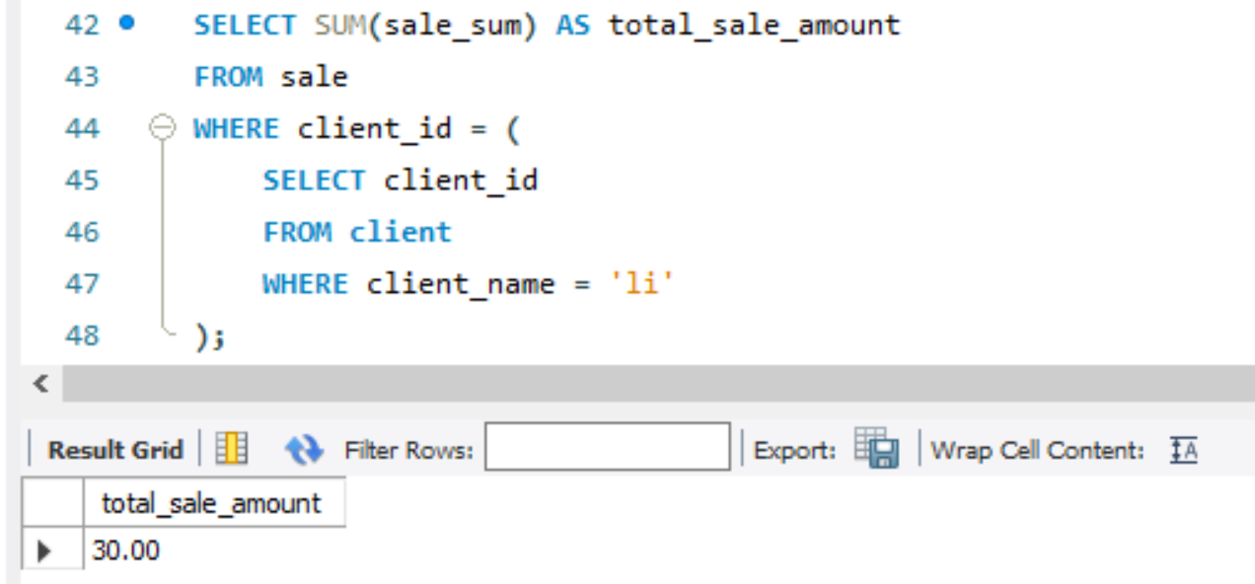

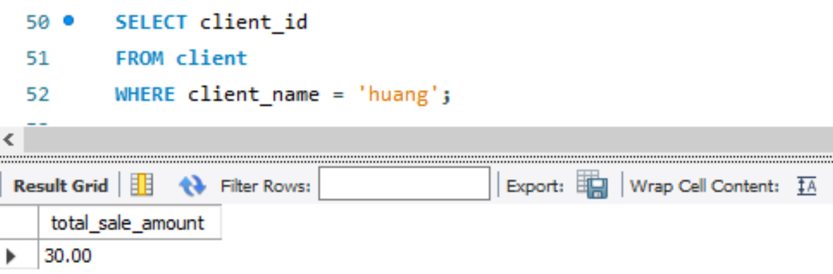

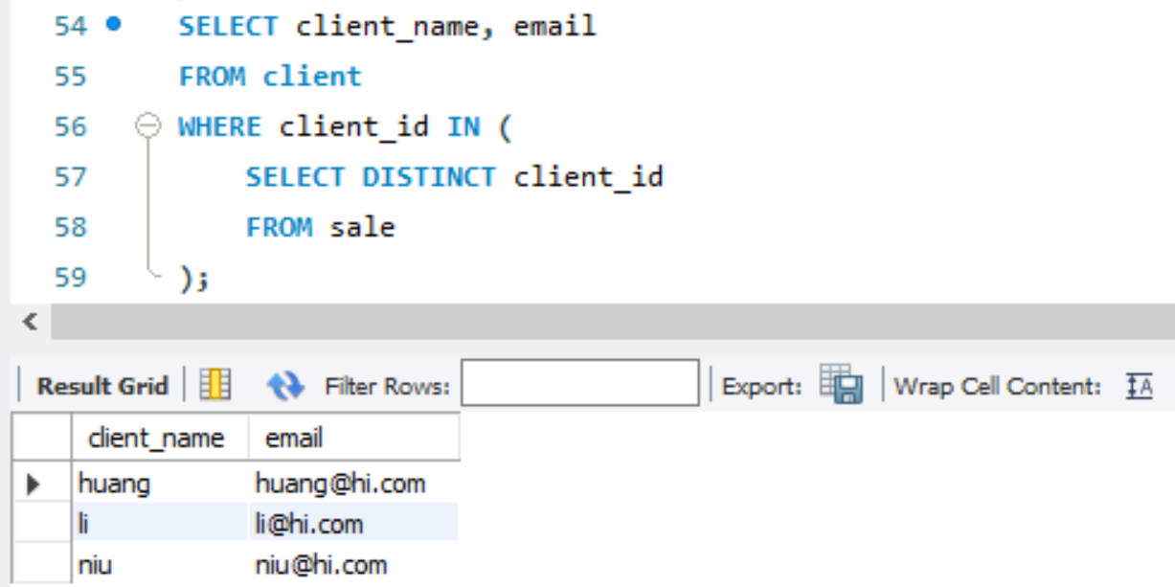

1. **Two queries**must be included using**group by and having.**

**GROUP BY:**

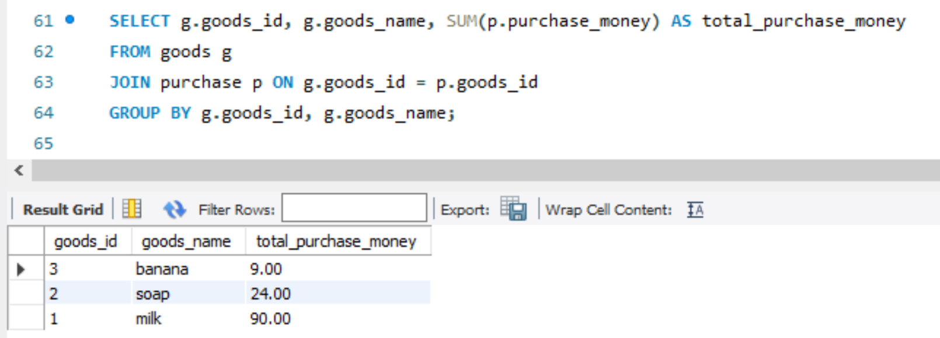

**HAVING:**

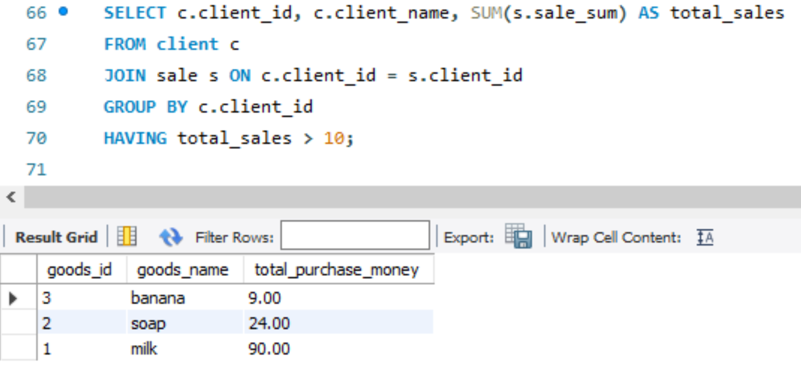

1. **Minimum two views**, which combined of two or three tables, must be included.

(A view is a virtual table based on the result of a SELECT query.)

**VIEW1:**

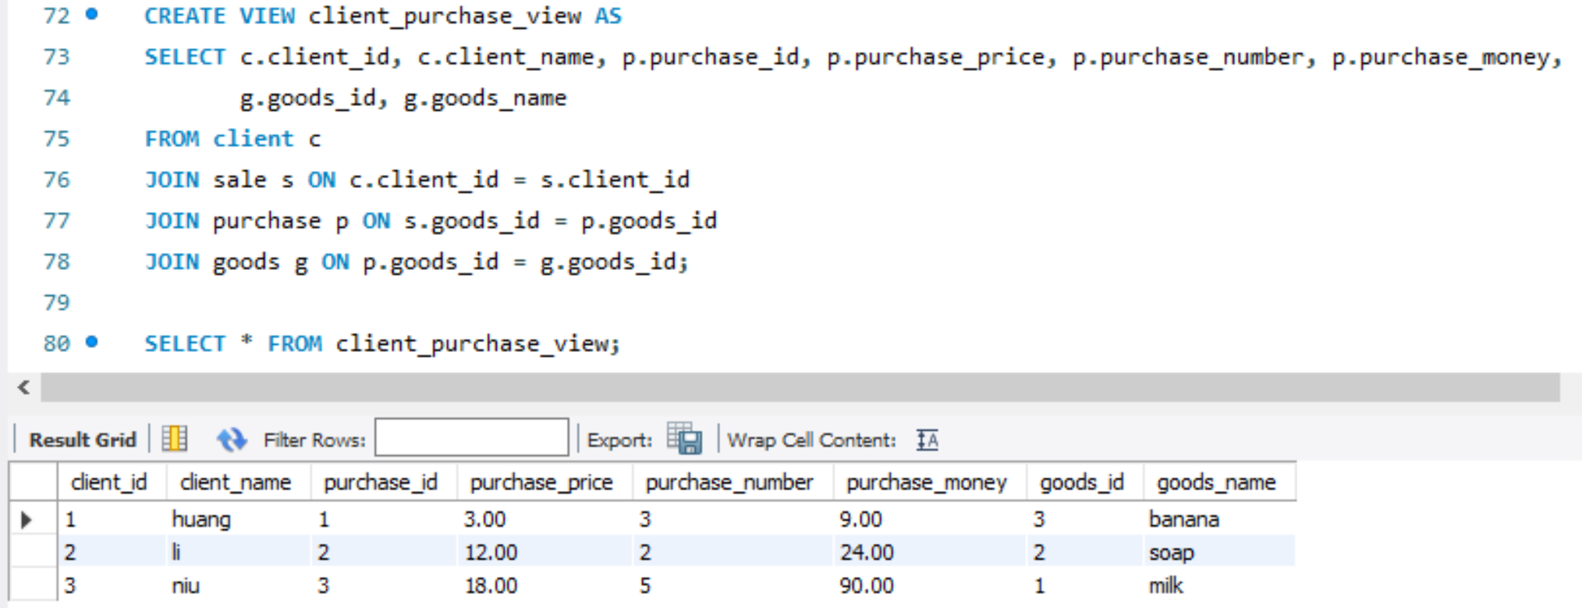

This view provides information about client along with details of their purchases and the corresponding goods.

**VIEW2**

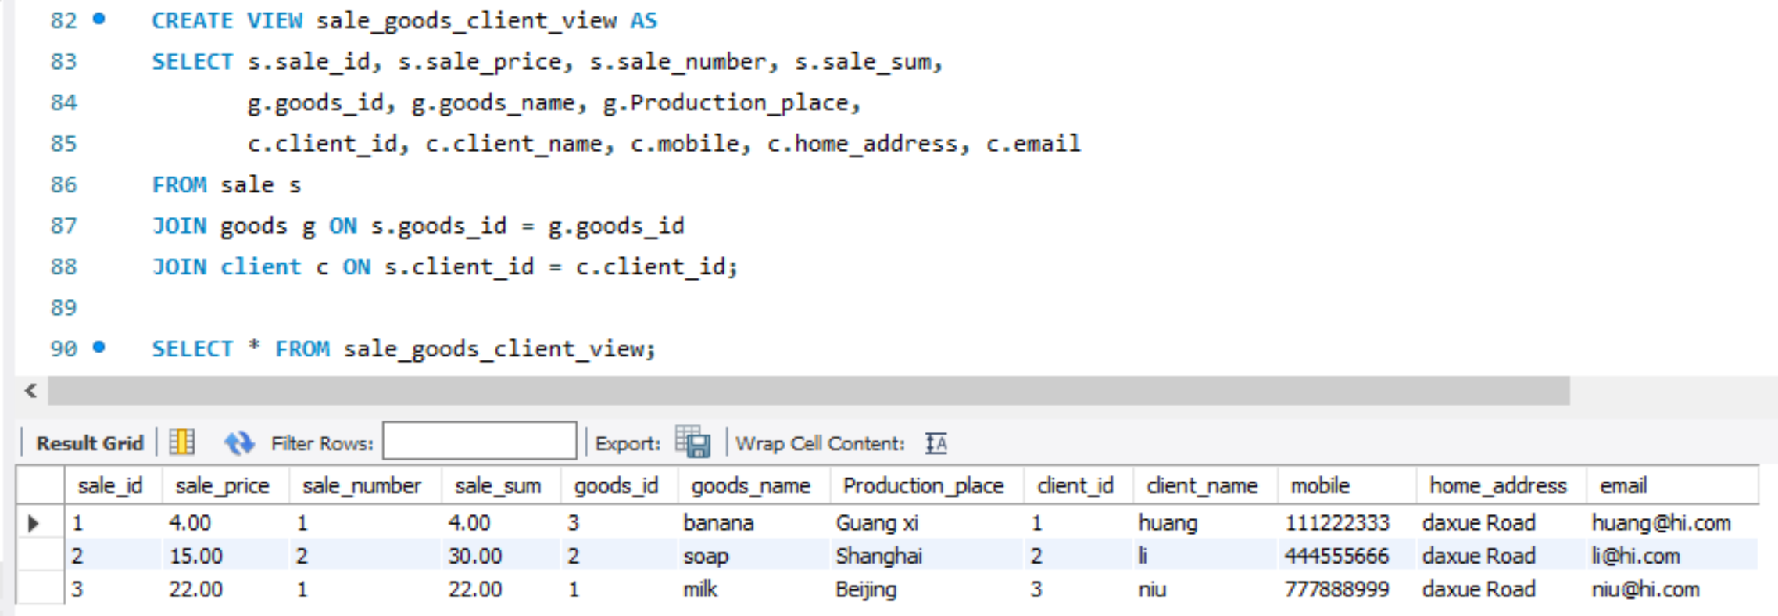

This view provides information about sales along with details of the corresponding goods and clients involved in those sales.

1. **One cursor and trigger must be included.**

**Cursor:**

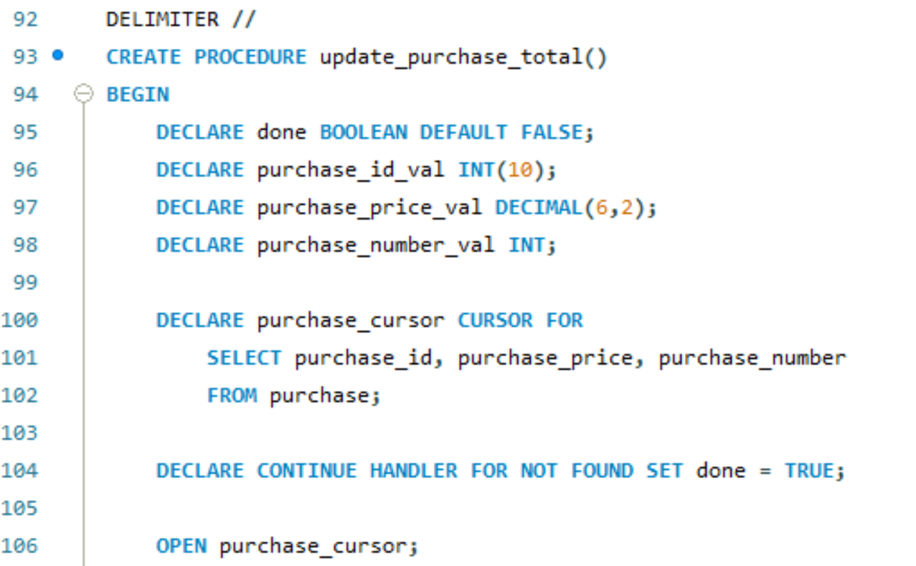

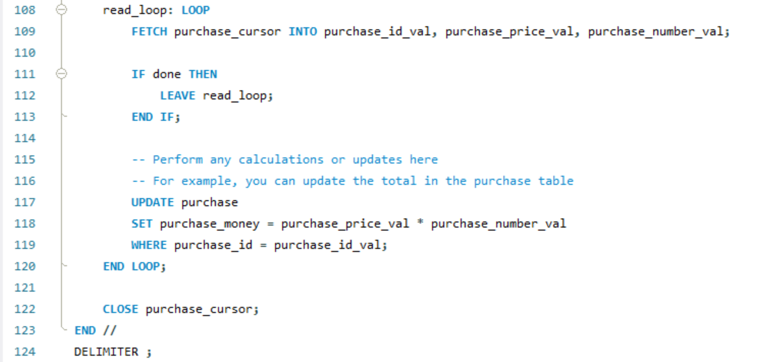

In the example procedure **update_purchase_total**, a **cursor** is declared to iterate through the records in the **purchase** table. Inside the loop, you can perform actions on each record. It updates the **purchase_money** column based on the product of **purchase_price** and **purchase_number**.

**Trigger:**

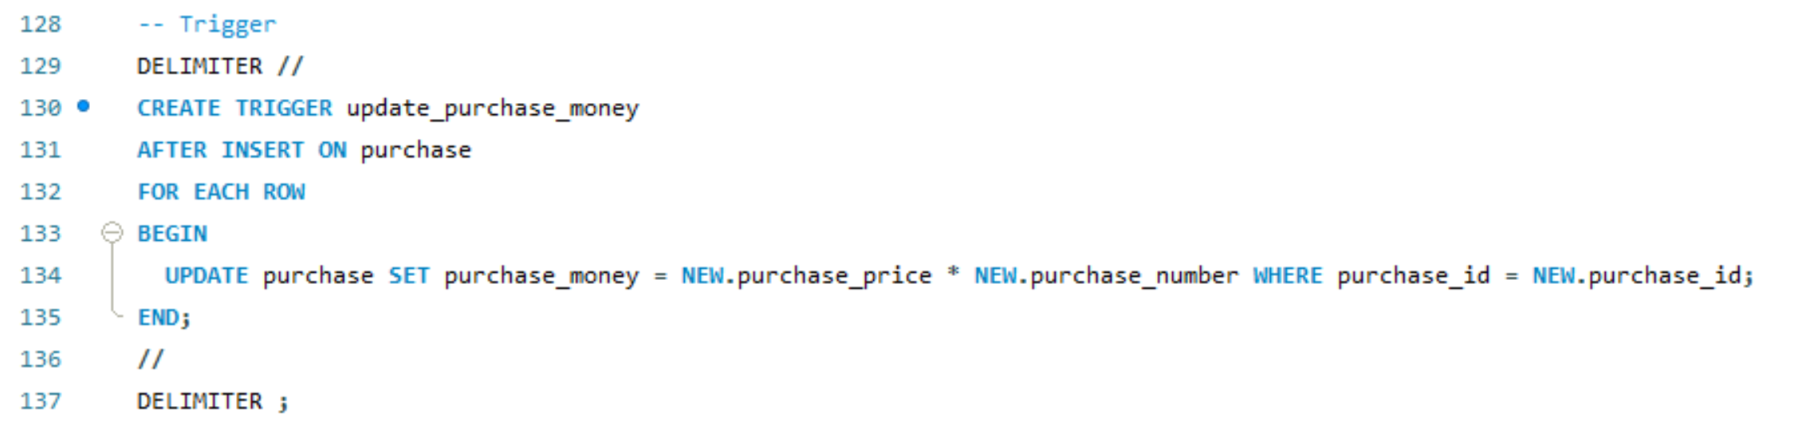

The trigger **update_purchase_money** automatically calculates and updates the **purchase_money** column in the **purchase** table after a new record is inserted. It uses the **AFTER INSERT** event and sets the **purchase_money** based on the product of the newly inserted **purchase_price** and **purchase_number**

1. Create an **application** for your MySQL schema. (Python)
2. Must have the **main form page**.
3. The user when open the database must directly show the **main form.**
4. Each table must have (**continues** form with **single** form).
5. For two tables should have a **report**.
6. The user when open the database must directly show the **main form.**

**Main form:**

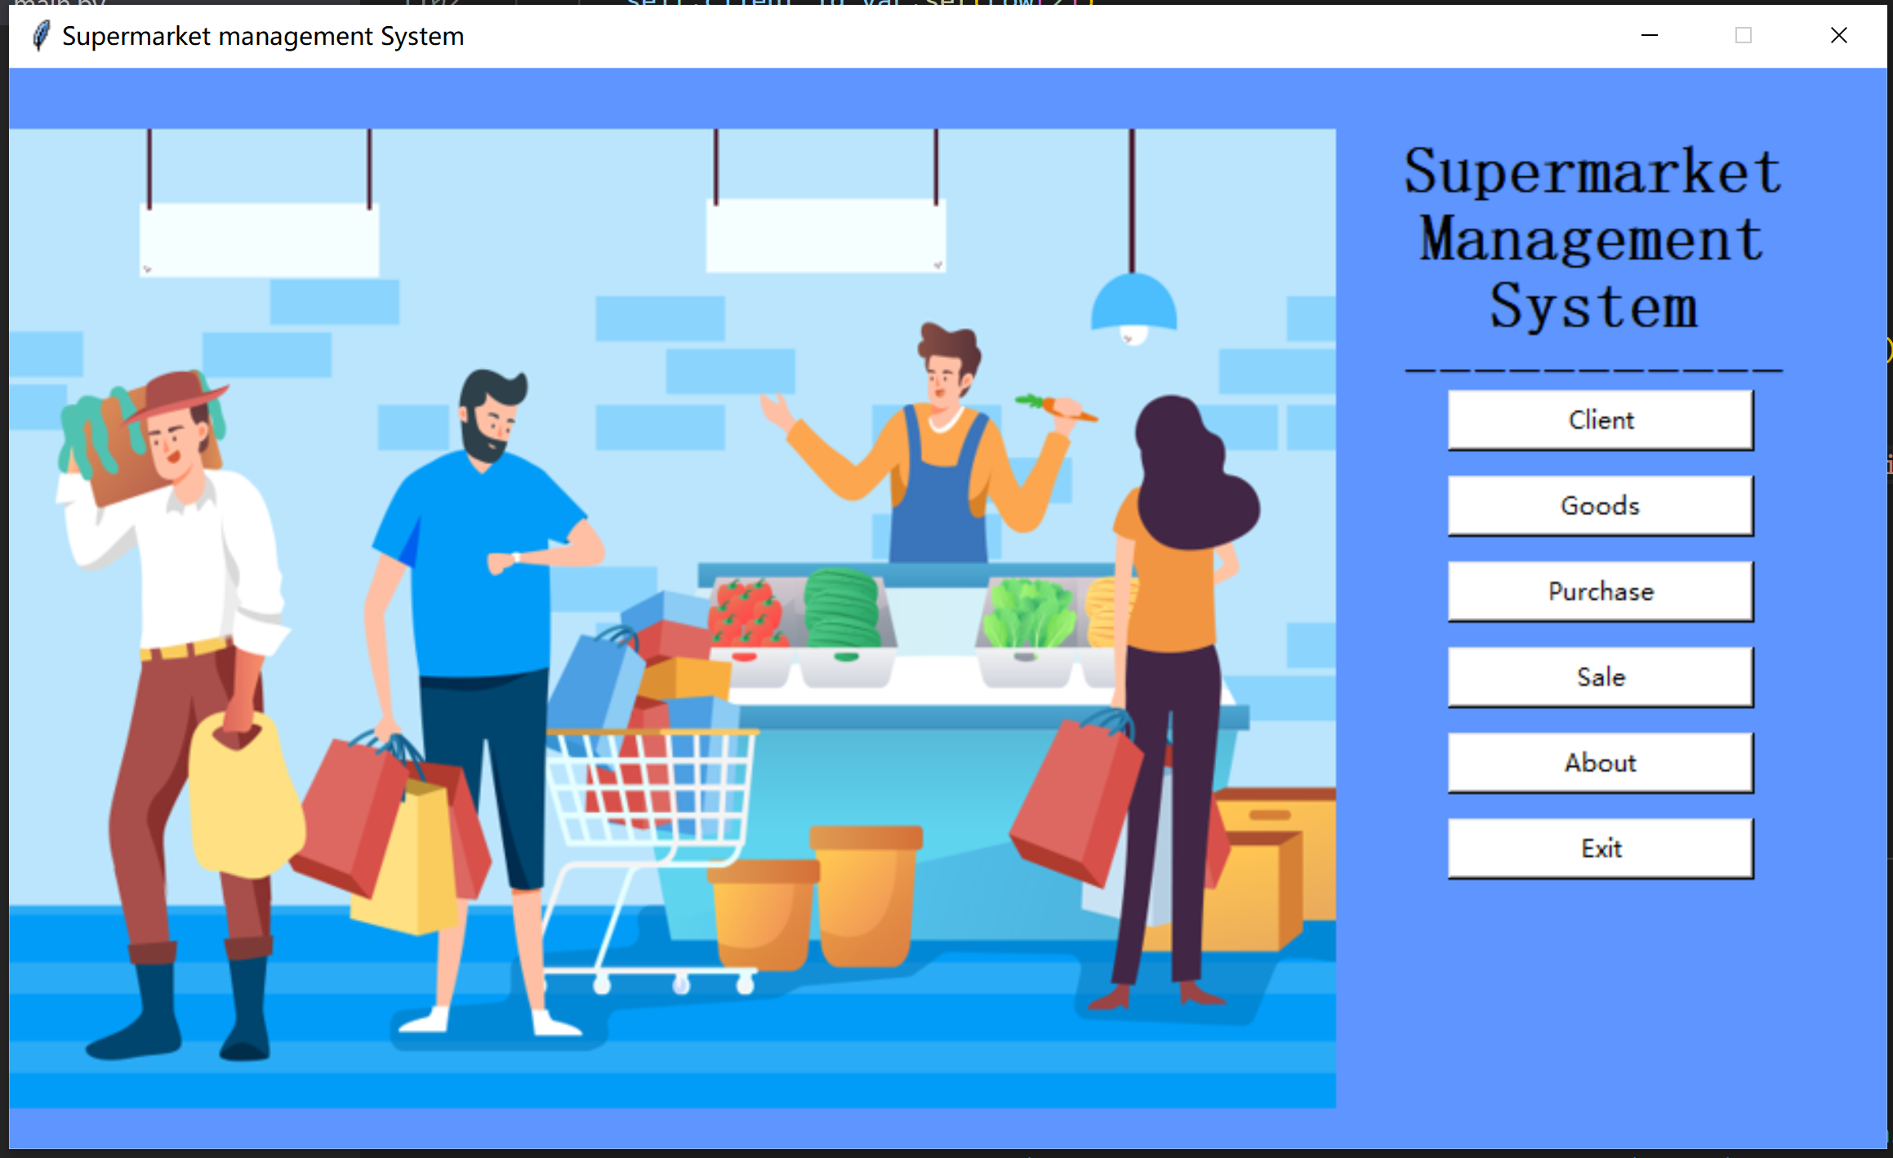

Code of the main form (includes the variables we need to use)

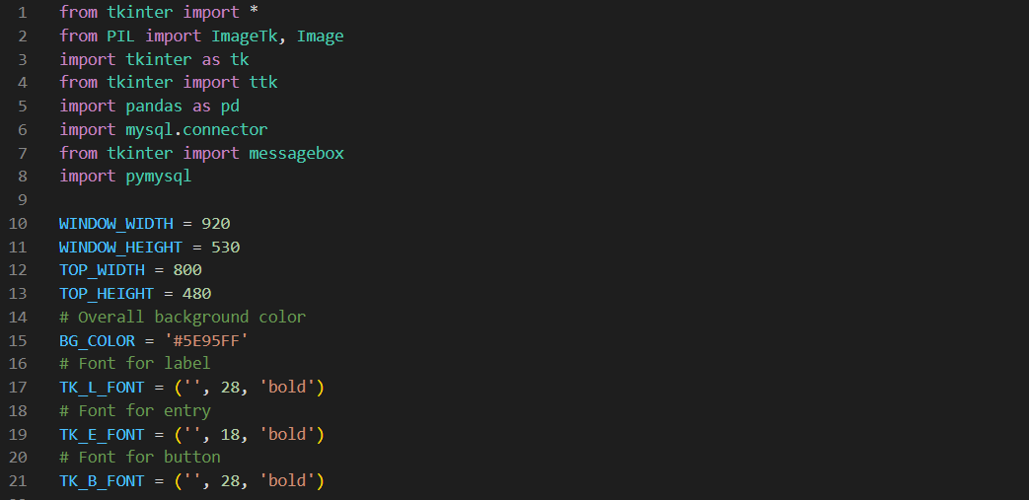

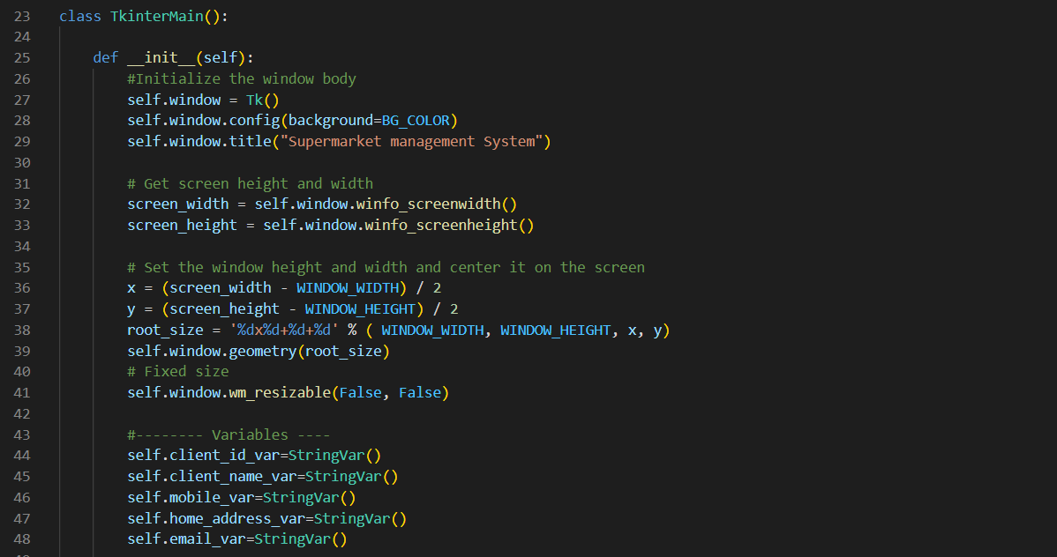

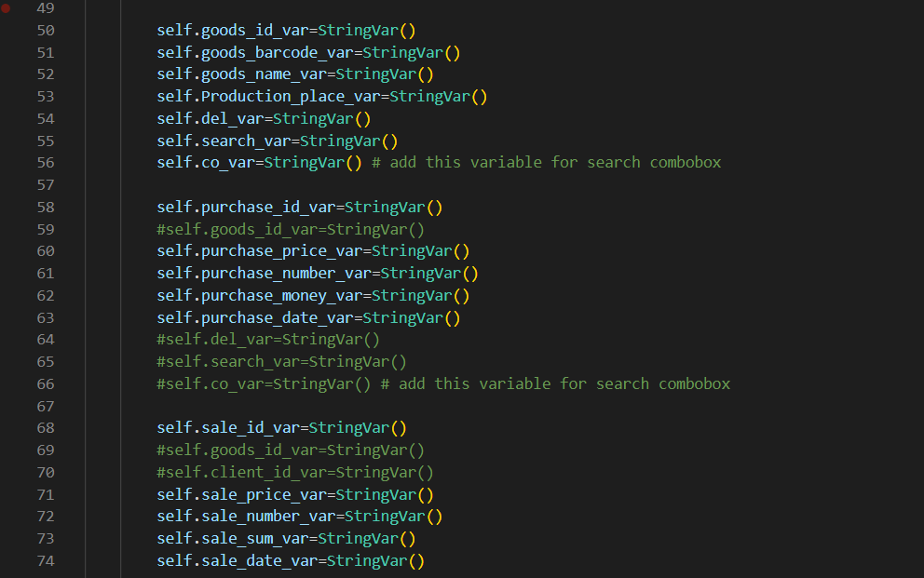

I defined and used the method show_top_view() to show the sub windows.

show_top_view() includes

self.top_view = Toplevel(background=BG_COLOR)

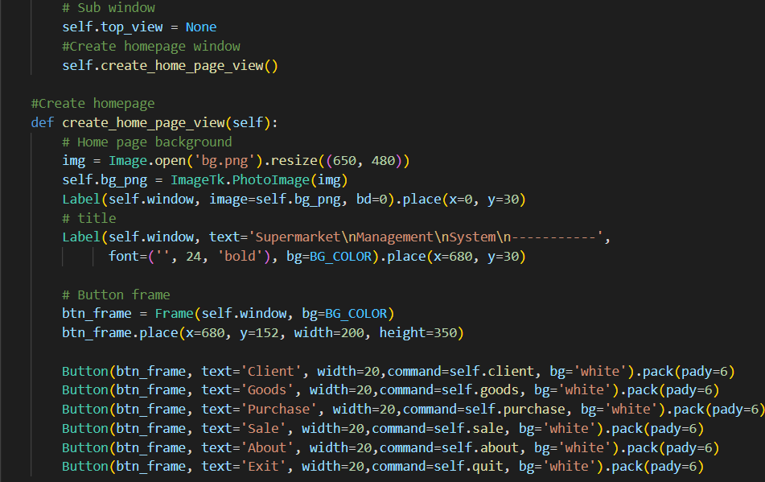

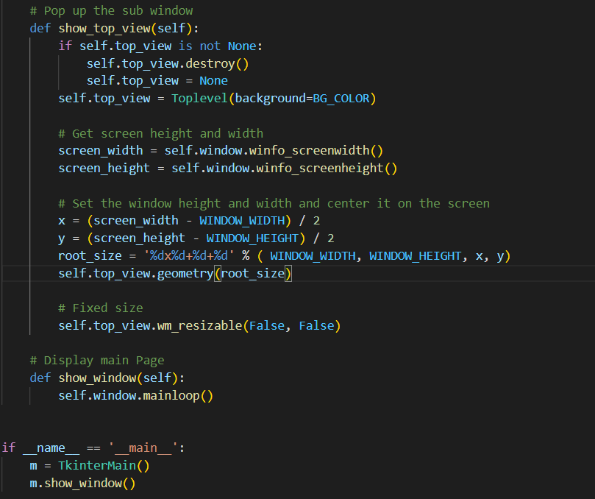

Click Button About 🡪 to see the information of me

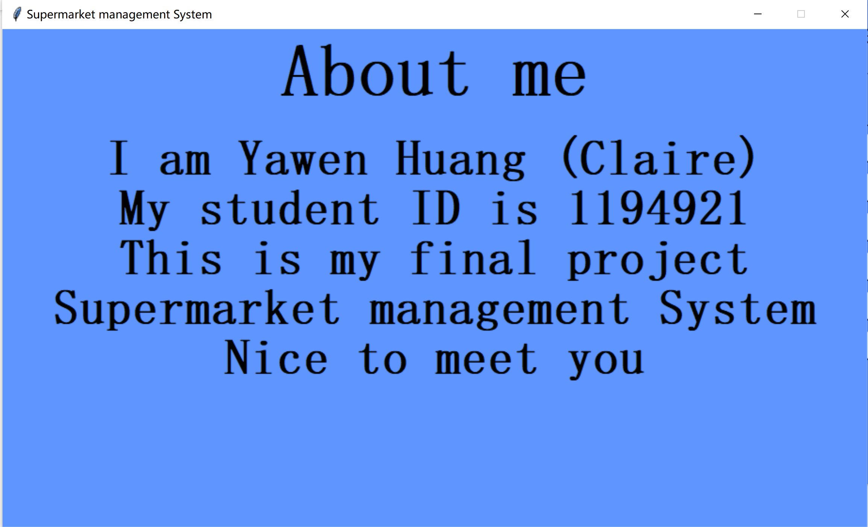

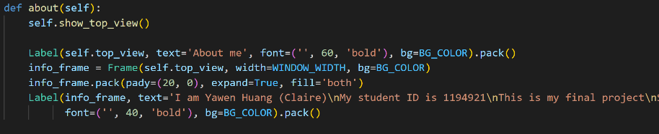

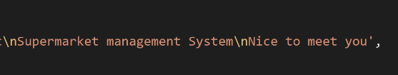Click Button Exit🡪

The main form links with the four tables I create in MySQL, you could enter the table interface through click the buttons:

For example, Click Button Client 🡪

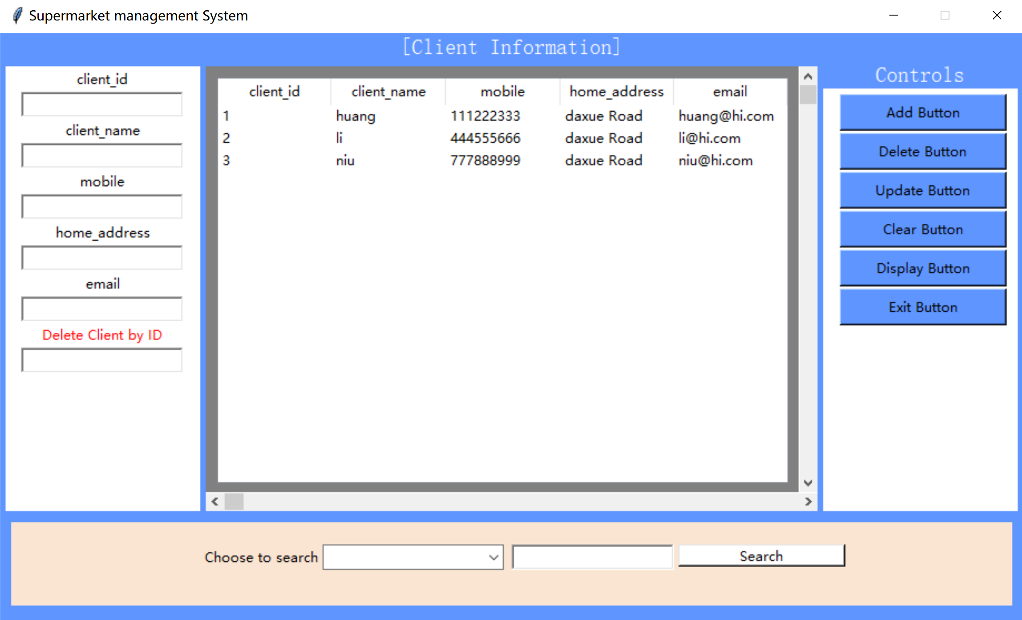

You could add, delete, update and search data by this application.

Add:

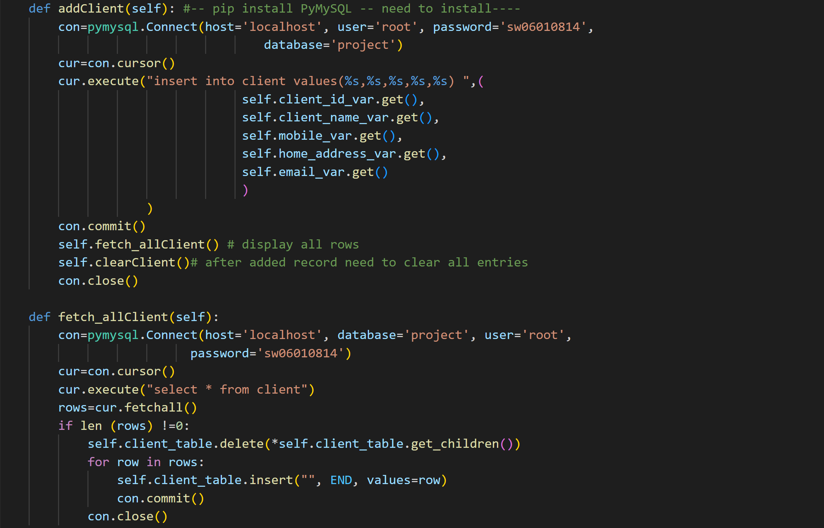

Delete:

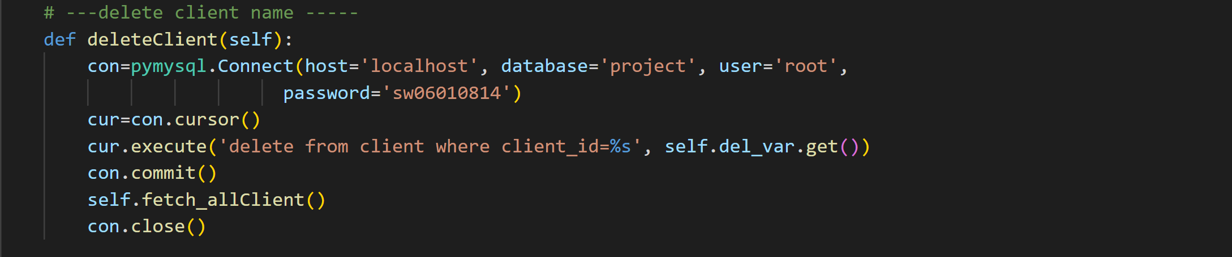

Update:

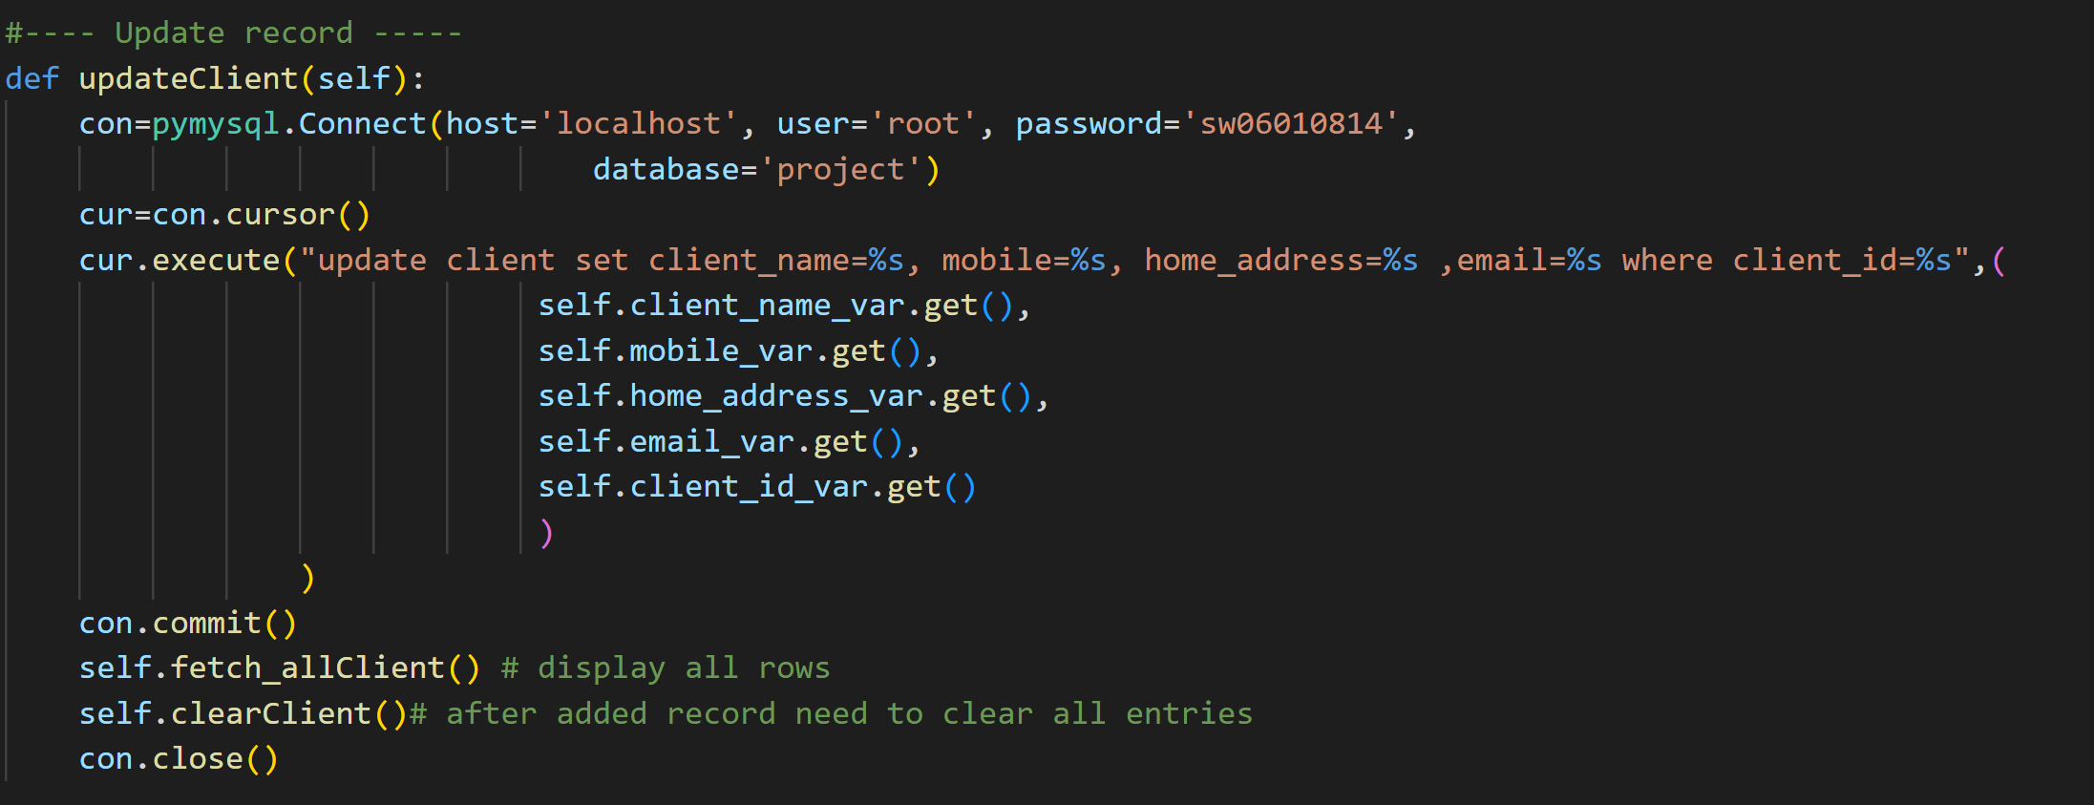

Clear:

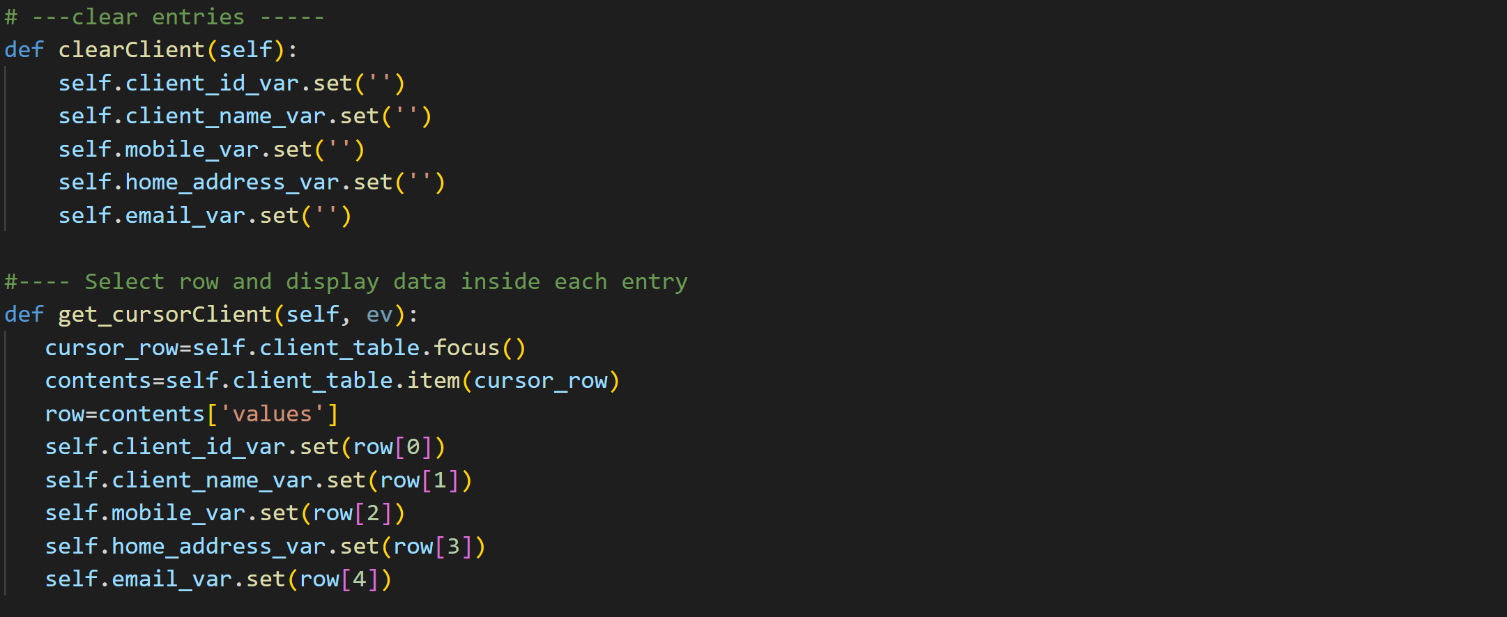

Search:

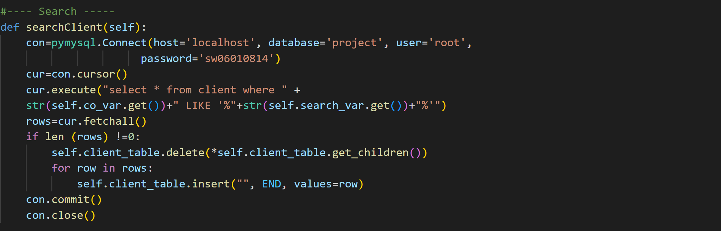

Also, you could Display the database information by click the Display Button.

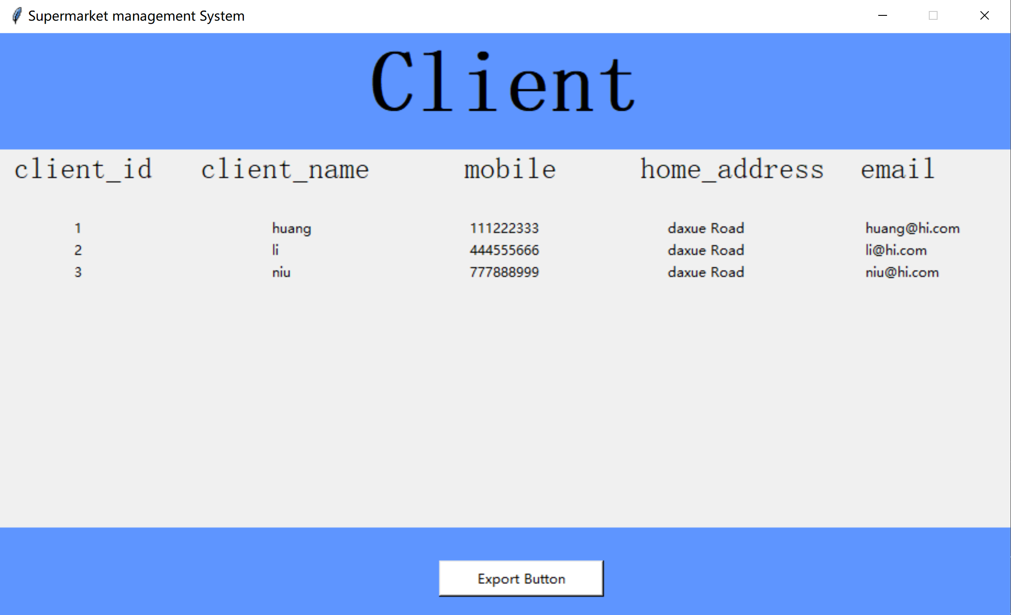

And you can also export it to an excel file, just click the export Button, then the application will generate a file under 'D:\project_excel'

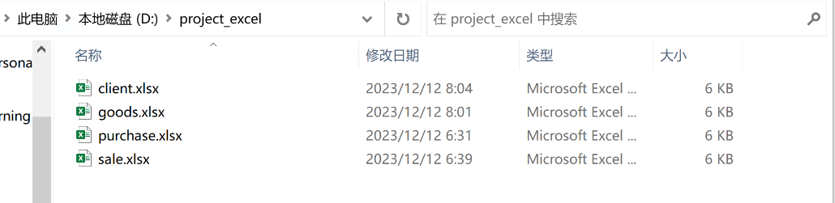

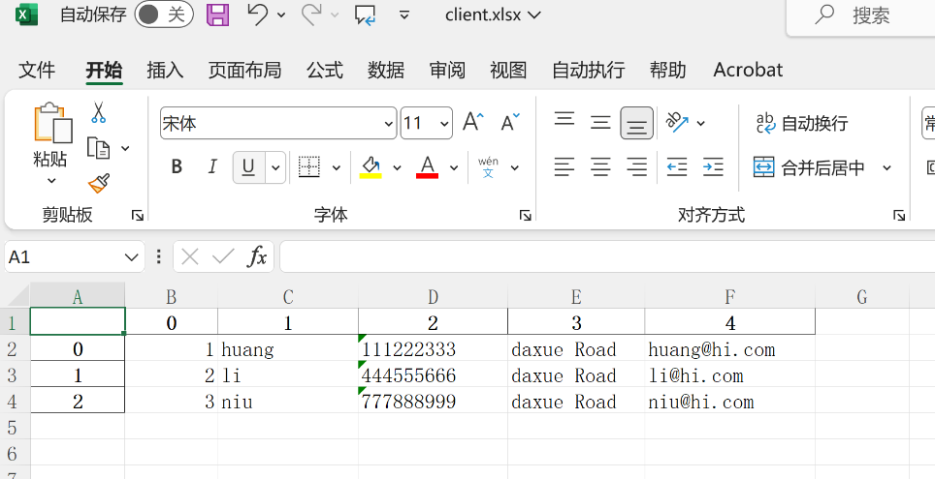

Click Button Goods 🡪

The method I used to display the report and export to excel:

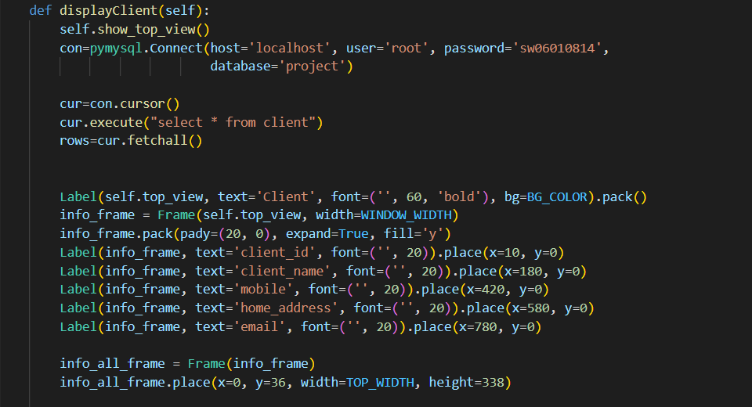

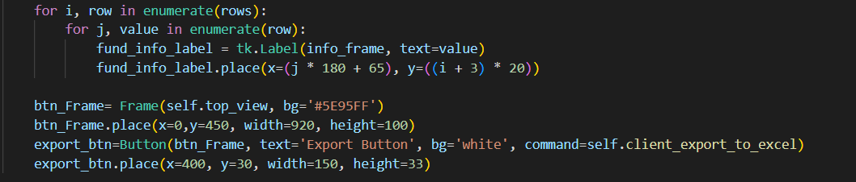

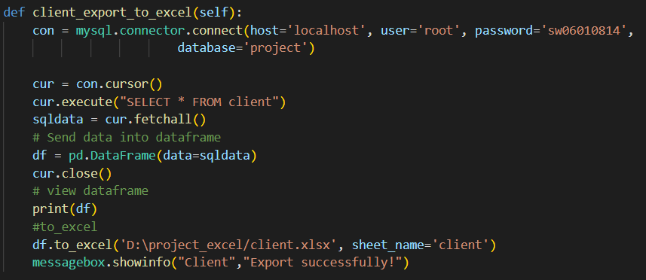

Because the page for 4 table is generally consistent, I will just show 2 of them to you.

Click Button Sale 🡪

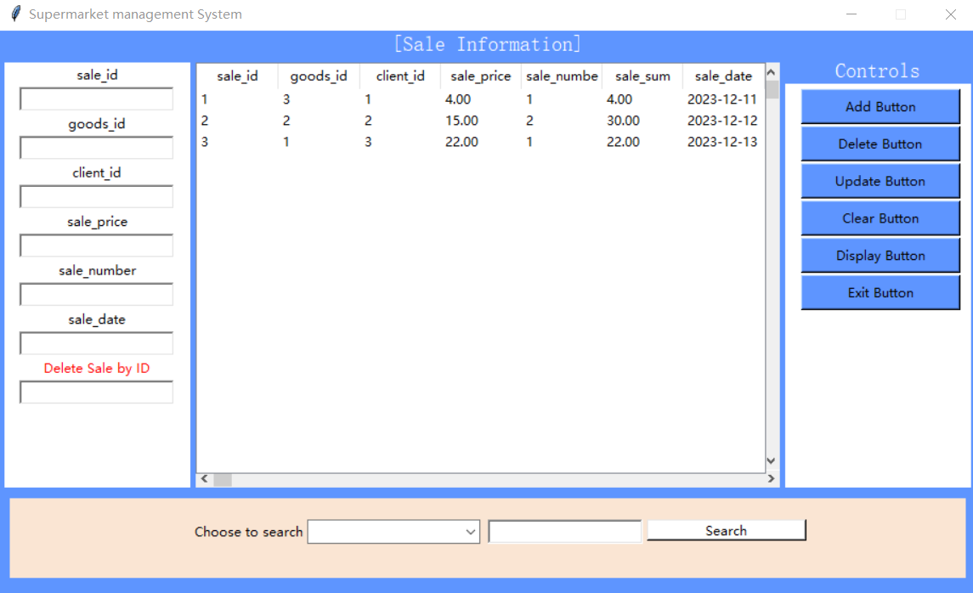

This page is slightly different from the previous one because you don’t need to input the sale_sum. The sale_sum would generate automatically.

1. Give the summary for your project plus what you learned in this semester, must be less than 300 words.

In this project, I used MySQL to create the schema and table and Python tkinter to complete the design of the application interface. I used PyMySQL to connect to the local database to add, delete, check and modify data. This project has trained me to write SQL language, and the ability to use Python tkinter to create a graphical interface. I learned how to build a database that can be interacted with, greatly benefiting me.

During the semester, I acquired skills in designing and implementing relational database schemas, ensuring data integrity through constraints, crafting intricate SQL queries with joins and set operations, and creating a primary application to interact with the database. Additionally, I garnered hands-on experience in utilizing Python tkinter to create the graphical interface and MySQL for practical applications. Furthermore, I gained theoretical understanding in areas such as database design paradigms, transactions, and concurrency control. This information will be extremely useful in my future database design and optimization work.